Cloud Computing Systems
# Source: Chatgpt (GPT-5-Mini) at [1/16/2026]
A Cloud Computing System is a type of distributed system where computing resources—such as storage, processing power, and software—are provided to users over the Internet as a service.
Users can access resources on-demand without owning or managing the underlying hardware.

Definition
# Source: Chatgpt (GPT-5-Mini) at [1/16/2026]
A Cloud Computing System:
- Provides on-demand access to computing resources
- Resources are hosted in data centers distributed across the globe
- Offers services like Infrastructure, Platform, or Software as a Service (IaaS, PaaS, SaaS)
- Resources are scalable, flexible, and pay-as-you-go

Architecture Diagram
# Source: Chatgpt (GPT-5-Mini) at [1/16/2026]
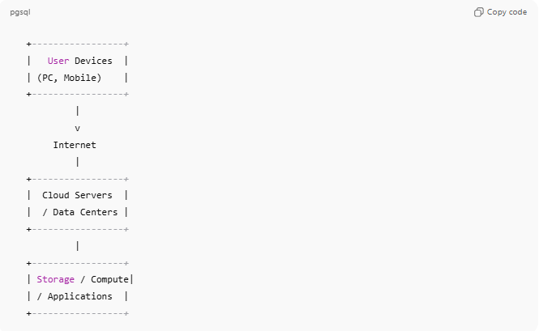
+-----------------+
| User Devices |
| (PC, Mobile) |
+-----------------+
|
v
Internet
|
+-----------------+
| Cloud Servers |
| / Data Centers |
+-----------------+
|
+-----------------+
| Storage / Compute|
| / Applications |
+-----------------+

How Cloud Computing Works
# Source: Chatgpt (GPT-5-Mini) at [1/16/2026]
- Users send requests via Internet (web browser, mobile app, or API)
- Cloud system dynamically allocates resources (CPU, storage, memory)
- Resources process requests, store data, or run applications
- Results are sent back to the user

Key Characteristics
# Source: Chatgpt (GPT-5-Mini) at [1/16/2026]
- On-demand self-service: Users can provision resources without human intervention
- Broad network access: Accessible from any Internet-connected device
- Resource pooling: Multiple users share resources dynamically
- Rapid elasticity: Can scale up or down automatically
- Measured service: Users pay only for the resources they use

Types of Cloud Services
# Source: Chatgpt (GPT-5-Mini) at [1/16/2026]
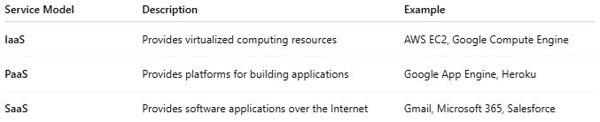
Service Model | Description | Example
IaaS | Provides virtualized computing resources | AWS EC2, Google Compute Engine
PaaS | Provides platforms for building applications | Google App Engine, Heroku
SaaS | Provides software applications over the Internet | Gmail, Microsoft 365, Salesforce

Applications
# Source: Chatgpt (GPT-5-Mini) at [1/16/2026]
- File storage and backup (Google Drive, Dropbox)
- Web hosting and content delivery
- Big data analytics (AWS, Google Cloud)
- Artificial Intelligence and Machine Learning platforms
- Enterprise applications (ERP, CRM)

Advantages
# Source: Chatgpt (GPT-5-Mini) at [1/16/2026]
- Cost-effective (no need to buy hardware)
- Highly scalable and flexible
- Accessible from anywhere
- Easy collaboration and resource sharing
- Automatic software updates

Disadvantages
# Source: Chatgpt (GPT-5-Mini) at [1/16/2026]
- Requires Internet connectivity
- Security and privacy concerns
- Limited control over infrastructure
- Potential vendor lock-in

Simple Analogy
# Source: Chatgpt (GPT-5-Mini) at [1/16/2026]
- Cloud Computing: Renting an apartment instead of buying a house
  - You use the space and utilities as needed
  - Maintenance and infrastructure are handled by the provider

